REPORT

Blog Project

May 21, 2018

Okan ÇİFTÇİ

Göksu EREN

Çağla GEZGEN

[1 : Introduction ]

[2 : Project Goal ]

[3 : Sections ]

[4 : The technologies being used ]

[5 : References ]

# 1. Introduction

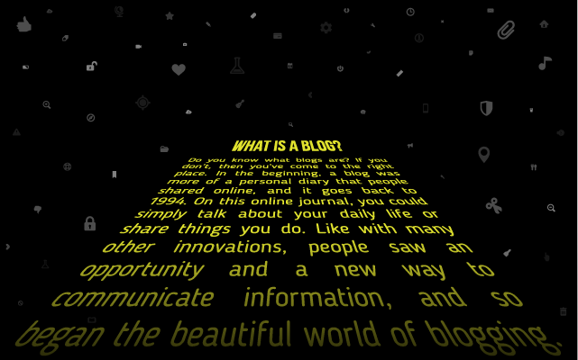

Nowadays blogs are so popular. A blog (shortening of “weblog”) is an online journal or informational website displaying information in the reverse chronological order, with latest posts appearing first. It is a platform where a writer or even a group of writers share their views on an individual subject.

We decide to create Blog website for Database and Web Programming final project. When project finished we realized that we learned too much.

# 2. Project Goal

This project main goal is understanding “how web works”, we are Computer Scientist students because of this reason we have to know how web works, so this project gave us so many information about this topic, in addition we learned RDBMS basics, ORM basics . If we talk about other goals, our application must be scalable. We use new technologies, and doing code reviews. Other goal is, we want develop a project which open source, so we upload this project on GitHub, everyone use this projects on their computers also they can publish on the internet. We have to use good design for end users, another goal is design must be sightly.

By this project, everyone which want use blog, can write blogs.

# 3. Sections

1. User Side

* Navbar

By this shortcut users can search in website or reach “Home”,“Blog”,”About Me”,”Contact” sections easily way.

* Slider

By this shortcut users can easily access blogs which determined by blog owner.

* Categories

By this section users can easily access categories, it’s good option for filter blogs.

* Top 5 Read Rate Blog

By this section users can easily access popular blogs.

* Blogs

By this section users can read description blogs also they can read blogs with details.

* Footer

By this section user can access social media links, they can reach blog owner social media accounts.

* About Me

By this section users can read blog owner paragraph which brief about owner.

* Contact

By this section users can send message to blog owner, they can communicate each other by this section.

* Comments

By this sub section users can write thoughts under the blog page.

1. Admin Side

* Login Page

Admin must enter password and e-mail, if this LoginModel valid so they can access Admin Panel

* Admin Panel

Admin can reach 3 sections

1. Blog Process
2. Category Process
3. Admin Process

* Blog Process

Admin can list, create, delete or check comments which wants.

* Category Process

Admin can list, create, delete categories.

* Admin Process
* Admin can register new account.
* Admin can look message list.
* Admin can look Admin List and also can delete admin.
* Admin can exit.
* Navbar

By this section admin can sections by easily way.

# 4. The Technologies Being Used

In this project we use too many different technologies.

* ASP.NET CORE

ASP.NET Core is a cross-platform, high-performance, [open-source](https://github.com/aspnet/home) framework for building modern, cloud-based, Internet-connected applications.

Our version is 2.0.0

* MSSQL

MS SQL Server is a relational database management system (RDBMS) developed by Microsoft. This product is built for the basic function of storing retrieving data as required by other applications.

* Docker

Docker is a tool designed to make it easier to create, deploy, and run applications by using containers.

We use Docker, ASP.NET Core supports macOS but MSSQL can’t support macOS therefore we use MSSQL via Docker.

* Entity Framework Core

Entity Framework (EF) Core is a lightweight, extensible, and cross-platform version of the popular Entity Framework data access technology.

* Object Relational Model

Object-Relational Mapping (ORM) is a technique that lets you query and manipulate data from a database using an object-oriented paradigm.

* Bootstrap

Bootstrap is a free front-end framework for faster and easier web development

Bootstrap also gives you the ability to easily create responsive designs

* Editor

We use Visual Studio Code.

* MVC

The Model-View-Controller (MVC) is an architectural pattern that separates an application into three main logical components: the model, the view, and the controller. Each of these components are built to handle specific development aspects of an application. MVC is one of the most frequently used industry-web

development framework to create scalable and extensible projects. standard

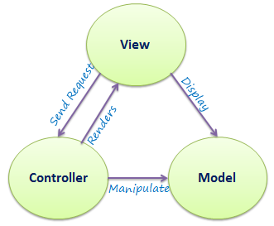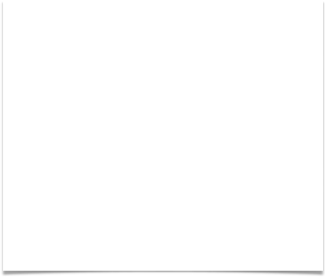

* N-tier Architecture

N-tier Architecture is a client-server architecture in which, the presentation, the application processing and the data management are logically separate processes.

* CKEDITOR

CKEditor is a rich text editor which enables writing content directly inside of web pages or online applications. Its core code is written in Java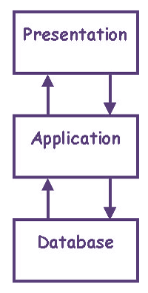Script and it is developed by CKSource.

* Identity Core

ASP.NET Core Identity is a membership system which allows you to add login functionality to your application. Users can create an account and login with a user name and password or they can use an external login provider such as Facebook, Google, Microsoft Account, Twitter or others.

* Asynchronous Programming

Asynchronous programming is a form of parallel programming that allows a unit of work to run separately from the primary application thread.

# 5. References

* <https://msdn.microsoft.com>
* <https://www.udemy.com>
* <https://www.youtube.com>
* <https://www.tutorialspoint.com/dotnet_core/index.htm>
* <https://hub.docker.com/r/microsoft/mssql-server-linux/>
* <https://getbootstrap.com>

Images

